**Chapter 6**

**Applications of Integration**

**6.9 Calculus of the Hyperbolic Functions**

**Section Exercises**

377. **[T]** Find expressions for  and  Use a calculator to graph these functions and ensure your expression is correct.

Answer:

379. Show that and  satisfy

Answer: Answers may vary

381. Derive  from the definition.

Answer: Answers may vary

383. Prove  by changing the expression to exponentials.

Answer: Answers may vary

**For the following exercises, find the derivatives of the given functions and graph along with the function to ensure your answer is correct.**

385. **[T]**

Answer: 

387. **[T]**

Answer: 

389. **[T]**

Answer: 

391. **[T]**

Answer: 

393. **[T]**

Answer: 

**For the following exercises, find the antiderivatives for the given functions.**

395. 

Answer: 

397. 

Answer:

399. 

Answer: 

401. 

Answer: 

403. 

Answer: 

**For the following exercises, find the derivatives for the functions.**

405. 

Answer: 

407. 

Answer: 

409. 

Answer: 

411. 

Answer: 

**For the following exercises, find the antiderivatives for the functions.**

413. 

Answer: 

415. 

Answer:

417. 

Answer: 

**For the following exercises, use the fact that a falling body with friction equal to velocity squared obeys the equation **

419. Show that  satisfies this equation.

Answer: Answers may vary.

421. **[T]** Estimate how far a body has fallen in  seconds by finding the area underneath the curve of 

Answer: 

**For the following exercises, use this scenario: A cable hanging under its own weight has a slopethat satisfies  The constant is the ratio of cable density to tension.**

423. Integrate  to find the cable height  if 

Answer: 

**For the following exercises, solve each problem.**

425. **[T]** A chain hangs from two posts  m apart to form a catenary described by the equation  Find the slope of the catenary at the left fence post.

Answer: 

427. **[T]** A high-voltage power line is a catenary described by  Find the ratio of the area under the catenary to its arc length. What do you notice?

Answer: 

429. Prove the formula for the derivative of  by differentiating  (*Hint:* Use hyperbolic trigonometric identities.)

Answer: This is a proof; therefore, no answer is provided.

431. Prove the formula for the derivative of  by differentiating  (*Hint:* Use hyperbolic trigonometric identities.)

Answer: This is a proof; therefore, no answer is provided.

433. Prove the expression for  Multiply  by  and solve for  Does your expression match the textbook?

Answer: This is a proof; therefore, no answer is provided.

**Chapter Review Exercises**

***True or False*. Justify your answer with a proof or a counterexample.**

435. The amount of work to pump the water out of a half-full cylinder is half the amount of work to pump the water out of the full cylinder.

Answer: False

437. The disk method can be used in any situation in which the washer method is successful at finding the volume of a solid of revolution.

Answer: False

**For the following exercises, use the requested method to determine the volume of the solid.**

439. The volume that has a base of the ellipse  and cross-sections of an equilateral triangle perpendicular to the Use the method of slicing.

Answer: 

441.  and  rotated around the *y*-axis using the washer method

Answer: 

**For the following exercises, find**

1. **the area of the region,**
2. **the volume of the solid when rotated around the *x*-axis, and**
3. **the volume of the solid when rotated around the *y*-axis. Use whichever method seems most appropriate to you.**

443. 

Answer: a. b. c. 

445. **[T]**

Answer: a. b. c.

447.    and 

Answer: a.  b.  c. 

449. Find the mass of  on a disk centered at the origin with radius.

Answer:

451. Find the mass and the center of mass of  on the region bounded by  and 

Answer: Mass: , center of mass:

**For the following exercises, find the requested arc lengths.**

453. The length of  for  from to 

Answer:

**For the following exercises, find the surface area and volume when the given curves are revolved around the specified axis.**

455. The loudspeaker created by revolving  from to  around the *x*-axis.

Answer: Volume:  surface area: 

**For the following exercises, consider the Karun-3 dam in Iran. Its shape can be approximated as an isosceles triangle with height m and width m. Assume the current depth of the water is m. The density of water is  kg/m**

457. You are a crime scene investigator attempting to determine the time of death of a victim. It is noon and  outside and the temperature of the body is °F. You know the cooling constant is When did the victim die, assuming that a human’s temperature is ?

Answer:  a.m.

**For the following exercises, consider the catenoid, the only solid of revolution that has a minimal surface, or zero mean curvature. A catenoid in nature can be found when stretching soap between two rings.**

459. Find the volume of the catenoid  from that is created by rotating this curve around the *x*-axis, as shown here.

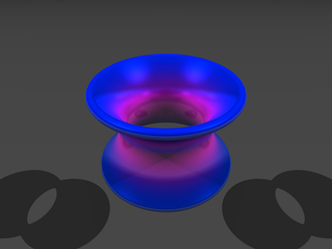

Answer: 

This file is copyright 2016, Rice University. All Rights Reserved.